1. What will be the output when the following code is executed?

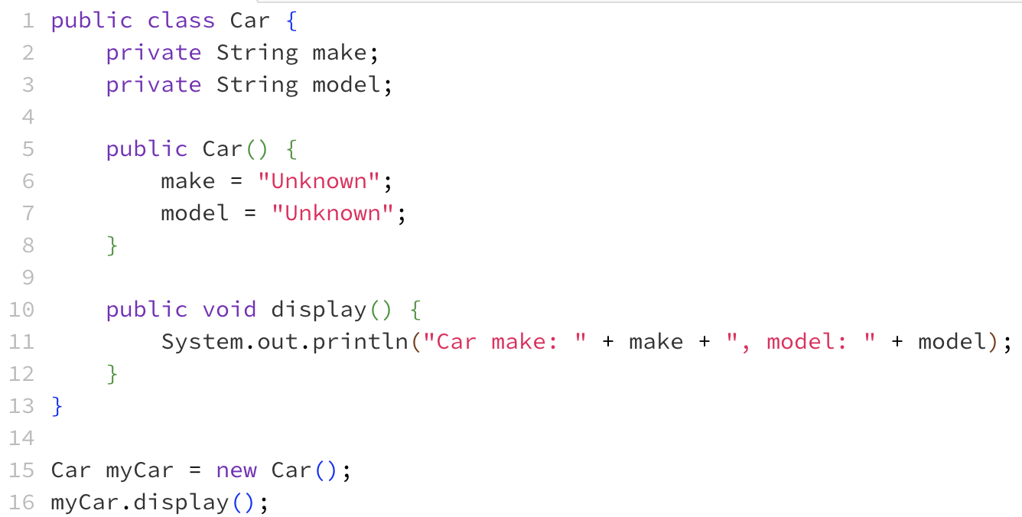

* **Car make: Unknown, model: Unknown**
* Car make: null, model: null
* Compilation Error
* Runtime Error

2. What access modifier should you use for a field that should not be accessed directly outside of its class but should be accessible through methods within the same class?

* public
* **private**
* protected
* package-private

3. What will be the output?

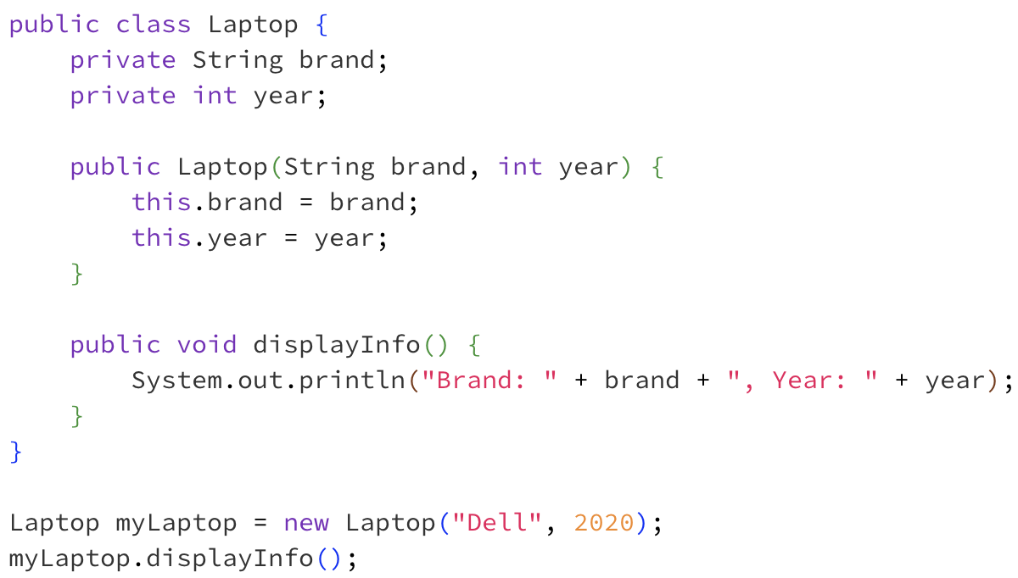

* **Brand: Dell, Year: 2020**
* Brand: null, Year: 0
* Compilation Error
* Runtime Error

4. Which of the following method definitions is incorrect based on its return type?

* public int calculateTotal(int a, int b) { return a + b; }
* public void printHello() { System.out.println("Hello"); }
* public double getPrice() { return 19.99; }
* **public String isAvailable() { System.out.println("Checking availability"); }**

5. Why is encapsulation important in object-oriented programming?

* It allows the class to be inherited.
* **It helps to protect the internal state of the object.**
* It allows the class to have multiple constructors.
* It enables method overloading.

6. What is the scope of a local variable defined within a method?

* Within the entire class
* Within the package
* **Within the method**
* Within the object

7. What is the purpose of the deposit method?

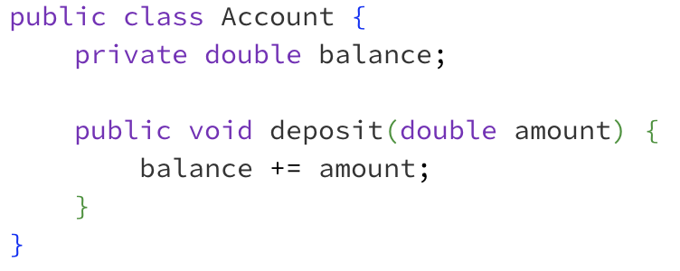

* To get the balance of the account
* To withdraw money from the account
* **To add money to the account**
* To transfer money to another account

8. In the following code, what is the purpose of using the this keyword?

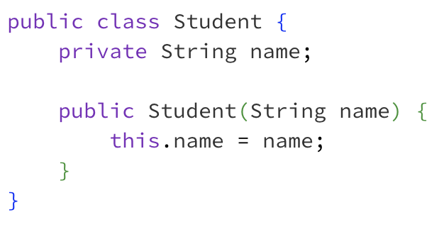

* **To refer to the current object**
* To create a new object
* To call a static method
* To return a value

9. Which of the following statements is true about static methods?

* They can access instance variables directly
* **They belong to the class rather than an instance of the class**
* They can be overridden in a subclass
* They require an object to be invoked

10. Which keyword is used to create a subclass in Java?

* **extends**
* implements
* inherits
* subclass

11. What is true about a default constructor?

* It takes one or more parameters
* **It is automatically provided by Java if no constructor is defined**
* It always initializes fields to non-default values
* It is required to throw exceptions

12. What is method overloading?

* Two methods in different classes with the same name
* Two methods in the same class with different return types
* **Two methods in the same class with the same name but different signatures**
* Two constructors in the same class with the same parameters

13. Which of the following is an accessor method?

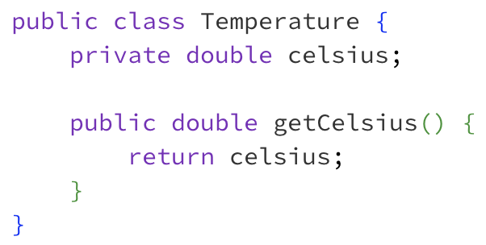

* **getCelsius()**
* setCelsius()
* displayCelsius()
* All of the above

14. What does a void return type in a method signify?

* The method returns a boolean value
* **The method does not return any value**
* The method returns an integer value
* The method returns a reference to an object

15. In Java, how are parameters passed to methods?

* By reference
* **By value**
* By object
* By pointer

16. What is the result of the following code?

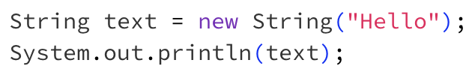

* **Hello**
* null
* Compilation Error
* Runtime Error

17. What is the term used to describe the order in which instructions and methods are executed within a program?

* Object Flow
* Method Order
* Execution Sequence
* **Control Flow**